

Android Description

For

Verizon Data Orchestration

Document Version: 1.0

Date: [30/12/2022]

Contents

1. Contents 2
2. Version Details 2
Overview 4
3. Introduction To ASN.1 4
3.1 Types of messages 5
4. Android-App: Setup 7
4.1 Android-App: Description 8
4.2 Speed Advisory Algorithm 12
5. Jenkins pipelines with sonarqube Integration 14
5.1 Setting up jenkins on Ubuntu-20.04 14
5.2 Setting up SonarQube on Ubuntu-20.04 18
6. CI/CD Integration Jenkins for android 28
6.1 Jenkins Installation 28
6.2 Configure Jenkins for Android 28
6.3 Setting up JDK 29
6.4 Setting up Android SDK Tools 29
6.5 Configure an Android project in Jenkins 31
6.6 Build Android Project 33
6.7 Archiving Artifacts (APKs) 33

Version Details

Please document all changes made to this document since initial distribution.

Versions | Amendments
1.2.08122022 | 1. User Login Page  2. Home Page with Publisher & Subscriber Navigation  3. Publisher screen with User Mode Carousel  Pedestrian: User can publish the PSM (Personnel Safety Message) details  General Vehicle: User can publish BSM (Basic Safety Message) details  Emergency Vehicle: User can publish EVA (Emergency Vehicle Alert) & RSA (Road Side Alert).  4. Subscribe Screen will display the data being subscribed from Verizon vRSU Server. Subscriber screen has the below functions;  Live Feed: Four Tab that differentiates and display the types of Data user receives.  GLOSA: Displays the Advisory Speed so as the immediate Traffic signal in approach is Green while crossing.  Signal Phase: Displays the Signal State of the upcoming Traffic Intersection
1.0.0 | 1. Introduced separate functional screen for subscribing  GLOSA Screen  2. Signal & Lane Advisory Screen  3. Fully Screen Live Feed Display with GLOSA & Signal Screen Navigation Button  4. JER Publishing and Subscribing  5. In Spat screen-- showing next intersection and signal status of connected lanes(including direction) according to current lane on which Vehicle is moving.

Overview
This document describes all the technical aspects of the data orchestration application.
The main motive of the application is to facilitates user to get the fined information about the lane or street in which they are travelling.

Android app is establishing direct connection with MQTT to publish and subscribe the data.
App uses ASN.1 (Abstract Syntax Notation One) encoding rules to publish the data to MQTT.
UPER & JER are the 2 encoded formats used by app.
For more details on ASN

Introduction To ASN.1
- Abstract Syntax Notation One (ASN.1) is a standard interface description language for defining data structures that can be serialized and deserialized in a cross-platform way.
- It is broadly used in telecommunications and computer networking, and especially in cryptography.
- Protocol developers define data structures in ASN.1 modules, which are generally a section of a broader standards document written in the ASN.1 language.
- ASN.1 is both human-readable and machine-readable, an ASN.1 compiler can compile modules into libraries of code, codecs, that decode or encode the data structures.
In the application we are using 2 encoding rules.
- UPER (Unaligned Packed Encoding Rules)
- JER (JSON Encoding Rules)

UPER: This Unaligned Packed Encoding are the most compact encoding rules. The goal of PER is to create smaller encodings. An advantage of using PER is the way it encodes data by examining constraints. PER does not send the Tag of the TLV since the order in which components of the message occur is known. PER also does not send the Length of the TLV if the Value has a fixed length. PER also uses additional information from the ASN.1 message description to eliminate redundant information from the Value portion of the TLV, thus making PER messages quite compact and suitable for environments in which bandwidth conservation is important.
For creation of UPER data, first we need to create a schema. Let us say my schema is,
BEGIN
FooBar ::= SEQUENCE {
Foo INTEGER (-512..511),
Bar INTEGER (-512..511)
}
END

Now, in case we need to encode below data:
test FooBar ::=
{
Foo 10,
Bar -10
}

It will be encoded as:
HEX: 0x829F60
BIN: 100000101001111101100000

Although, in our application we are directly using the ASN.1 libraries APIs to encode or decode the data.

JER: This JSON encoding rules was designed to allow applications to represent any ASN.1 value in JavaScript Object Notation (JSON). For example, an application that receives BER- or PER-encoded messages conforming to a certain ASN.1 schema will be able to re-encode the messages in JSON. This capability can be used to exchange data with other applications that do not understand ASN.1 but know how to parse or write JSON.
Below is the example of JER data for MAP being published to MQTT.

Types of messages
- BSM: The basic safety message (BSM) is used in a variety of applications to exchange safety data regarding vehicle state. This message is broadcast frequently to surrounding vehicles with data content as required by safety and other applications. Transmission rates are beyond the scope of this standard, but a rate 10 times per second is typical when congestion control algorithms do not prescribe a reduced rate.

- PSM: The Personal Safety Message (PSM) is used to broadcast safety data regarding the kinematic state of various types of Vulnerable Road Users (VRU), such as pedestrians, cyclists, or road workers. Data items which are optional are included in a PSM as needed according to policies that are beyond the scope of this standard.

- EVA: The emergency vehicle alert message is used to broadcast warning messages to surrounding vehicles that an emergency vehicle (typically an incident responder of some type) is operating in the vicinity and that additional caution is required. The message itself is built on the original ATIS roadside alert message which in turn uses the common ITIS phrase list to both describe the event and provide advice and recommendation for travellers.
- SPaT: The signal phase and timing (SPAT) message is used to convey the current status of one or more signalized intersections. Along with the MSG_MapData message (which describes a full geometric layout of an intersection), the receiver of this message can determine the state of the signal phasing and when the next expected phase will occur. MAP: The MapData message is used to convey many types of geographic road information. At the current time, its primary use is to convey one or more intersection lane geometry maps within a single message. The map message content includes such items as complex intersection descriptions, road segment descriptions, high speed curve outlines (used in curve safety messages), and segments of roadway (used in some safety applications).

- MapData: message may convey descriptions of one or more geographic areas or intersections. The contents of this message involve defining the details of indexing systems that are in turn used by other messages to relate additional information (for example, the signal phase and timing via the SPAT message) to events at specific geographic locations on the roadway.

- RSA: This message is for alerting about roadway hazards; not for vehicle cooperative communications, mayday, or other safety applications. It is generally presumed that each receiving device is aware of its own position and heading; but, it is neither a requirement to receive and understand these messages, nor is having a local base map.

For above messages, we are using a unique identifier Key. Based on that key, we are using those messages in dashboard UI.
Sno | Type of message | Key
1 | BSM | BasicSafetyMessage
2 | PSM | PersonalSafetyMessage
3 | EVA | EmergencyVehicleAlert
4 | SPAT | SPAT
5 | MAP | MapData

Android-App: Setup

Step 1: Download Android Studio from below URL:
https://developer.android.com/studio?gclid=CjwKCAiAkfucBhBBEiwAFjbkr5PQcPGTamgQQqtrP_NrsNt6e3G8G4KhYLX45UxqI90-Sdhrx-yIJhoC9wAQAvD_BwE&gclsrc=aw.ds

Step 2: After downloading, please install that

Step 3: clone the project using git clone https://github.com/5GRealityLab/do_frontend.git

Step 4: go inside directory cd /Android_Merged_App

Step 5: Import the project in android studio

Step 6: In android studio click on Build option in upper menu bar
Step 7: Click on build apk
Step 8: A pop up will show in right bottom
Step 9: Click on locate apk
Step 10: Then you can use apk after transferring in your phone

Libraries Used
Below are the libraries which are used in android application
Name | Purpose | License type
Google ProtoBuf | Communication | Public
Mqtt - Client | Communication | Eclipse Public
ASN1 (Java) | Communication | Evaluation
Google Play Services | Hardware communication | Public
MVVM Lifecycle | Code Architecture | Public
Retrofit | Register Api Handling | Public
Kotlin Coroutines | Communication | Public
Google Material ui | UI Attractive | Google Public
Gson | Json Hanlder | Google Public
Navigation Components | Bottom Navigation | Public
Data Binding | Bind the Data to View Object | Public
Speedometer | Advisory Speed | Public

Android-App: Description
Login Screen:
User authentication is performed using the login screen. User needs to enter the username and password and click on Login button to authenticate and login to the application.
Registration URL and MQTT URL can be left unchanged. If any invalid URL is entered, application will not get logged in even though user name password is correct.
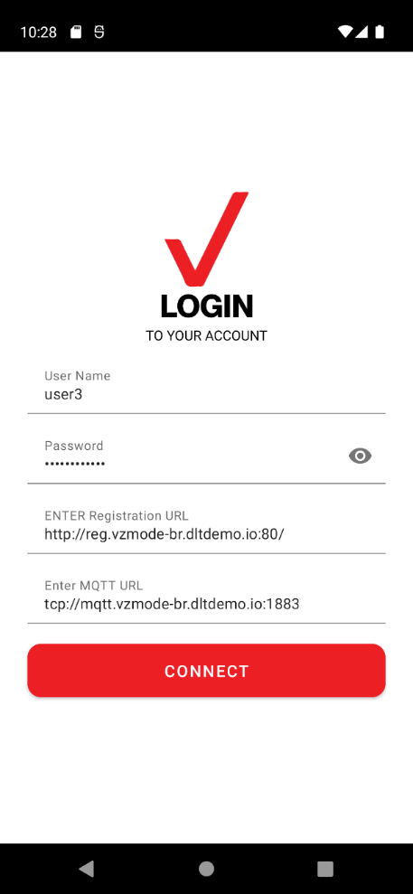

Home Screen Permission Request:
The application requires the following permissions to function
- Location Permission
- Phone Permission
If application is not having the required permission, on opening the application, user will be prompted with Alert dialogue to allow the permission.
Clicking on continue will take user to setting page, where permissions can be allowed.

Unless the required permissions are allowed, the alert dialogue will not get closed.

Home Screen
The home screen is the landing page, when the user successfully logins to the application.
This page will display a unique ID at the top with Logout button in as menu option.

Your Current Location: Displays the user’s current location and two buttons below it
The Publish button takes the user to Publish screen and Subscriber button takes the user to subscriber screen.

Publish Screen:
This screen is used to share the location details to other users. The user can select this publish mode as Publisher, General Vehicle or Emergency Vehicle.
The mode can be changed but swiping left or right in vehicle modes card.
The sharing can be started or stopped using the toggle button “Do you want to share your current/last location with others?”
The Emergency vehicle mode has an extra option where it can broad cast alerts to all users using the option “Do you want to Broadcast alerts” toggle button.
This mode will be displayed for Pedestrian and General Vehicle.
The published data can be viewed in Web Dashboard and in another application subscriber screen.

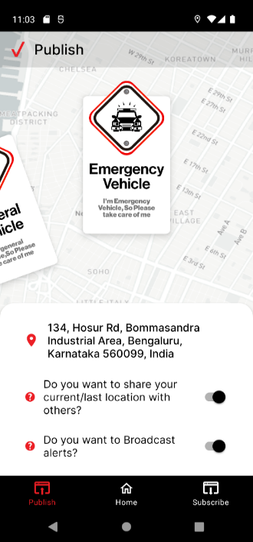
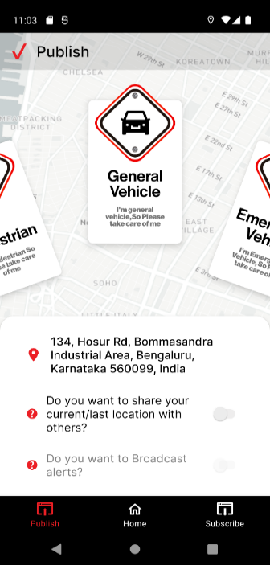
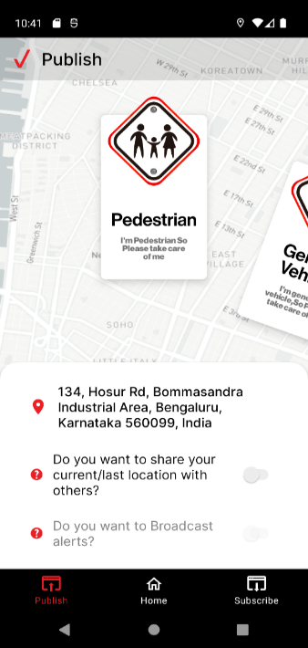

Subscriber Screen:
This screen is used to view all the feeds or applications that are publishing data.
The latitude longitude details speed and direction in which the publisher is moving will be displayed in subscriber screen.
Each vehicle mode can be differentiated with the different icons.
This screen also has tabs with icons such as All, Pedestrian, General Vehicle and Emergency vehicle to filter and view the data respectively in subscriber screen.
If an emergency vehicle is broadcasting alert, this screen will provide a sound alert and alert message to user to notify emergency

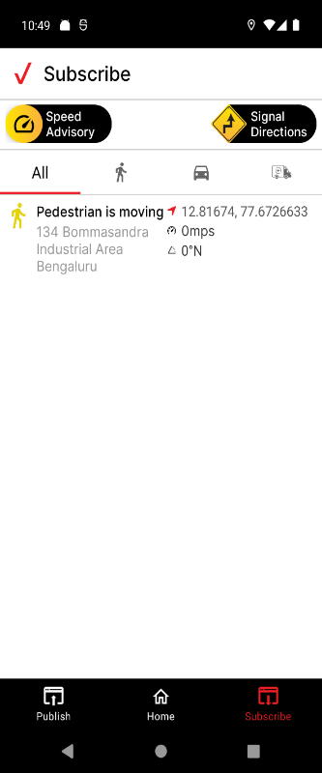
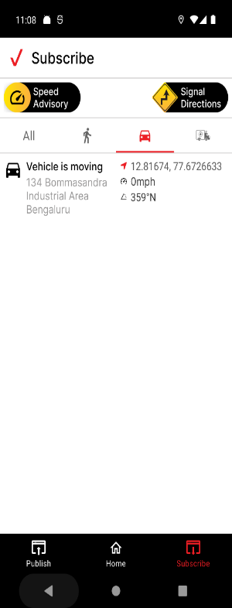
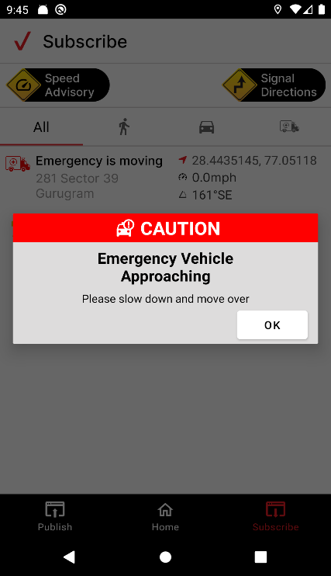

Speed Advisory Screen:
This screen displays the next upcoming signal, speed limit of the road in which you are travelling and advisory speed in which you need to travel to cross the signal without waiting.
At any cost Advisory speed will not exceed the speed limit.

Signal Directions Screen:
This screen indicates the current signal stage of the upcoming signal and will also indicate the seconds to geern or red light duration of the signal.

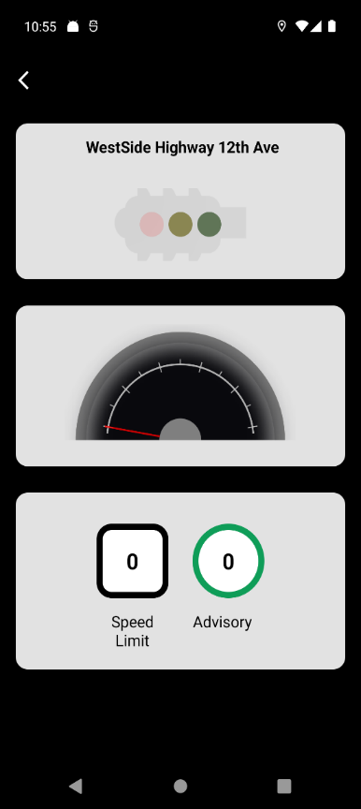
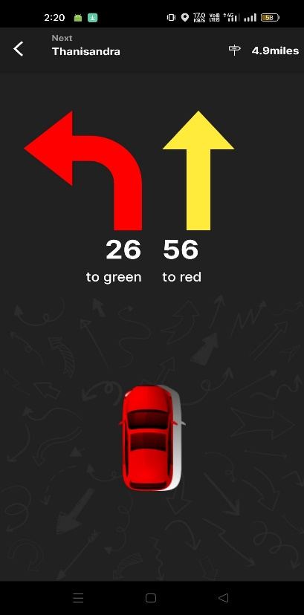

Speed Advisory Algorithm
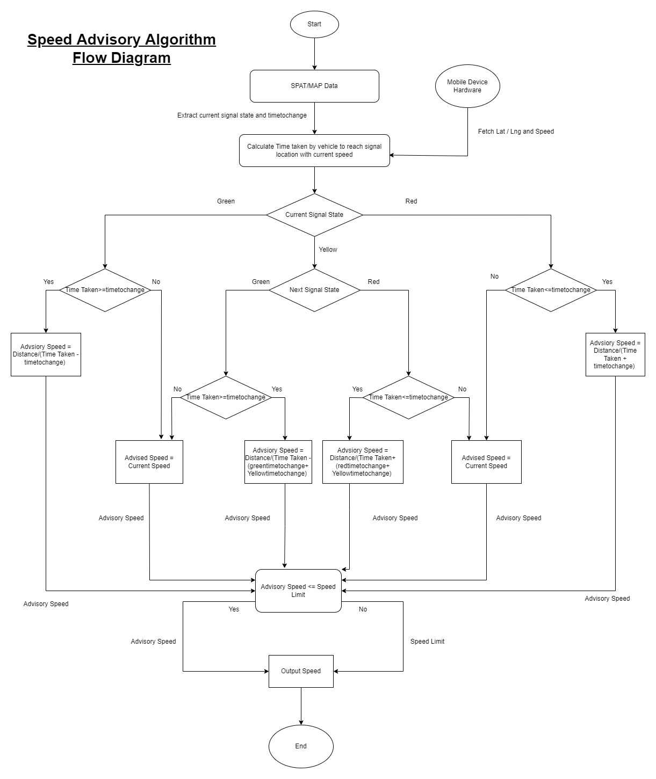

Step 1 - Fetch current state of signal, speed limit and timetochangesignal from SPAT.
Step 2 - Fetch signal location from MapData.

Step 3 - Fetch current location and speed of vehicle.

Step 4 - Calculate time to reach signal location with current speed.

Step 5 - Check if the current time to reach signal is less than the timetochangesignal and current signal is Red, then
Advisory Speed = Distance/(current time + timetochangesignal)
Step 6 - If the current time to reach signal is more than the timetochangesignal and current signal is Red, then
Advisory Speed = Current Speed
Step 7 - Check if the current time to reach signal is more than the timetochangesignal and current signal is Green, then
Advisory Speed = Distance/(current time - timetochangesignal)
Step 8 - If the current time to reach signal is less than the timetochangesignal and current signal is Green, then
Advisory Speed = Current Speed

Step 9 - If the current signal is yellow, we will check the next upcoming signal

Step 10 - Check if the current time to reach signal is more than the timetochangesignal and current signal is Green(After Yellow), then
Advisory Speed = Distance/(current time – (greentimetochangesignal) + (yellowtimetochangesignal))
Step 11 - If the current time to reach signal is less than the timetochangesignal and current signal is Green(After Yellow), then
Advisory Speed = Current Speed

Step 12 - Check if the current time to reach signal is less than the timetochangesignal and current signal is Red(After Yellow), then
Advisory Speed = Distance/(current time + (redtimetochangesignal) + (yellowtimetochangesignal))
Step 13 - If the current time to reach signal is more than the timetochangesignal and current signal is Red(After Yellow), then
Advisory Speed = Current Speed
Step 14 - If the Advisory Speed is within the Speed limit, then we will show the same Advisory Speed to UI, Otherwise we will show Speed limit as Advisory Speed.

Current Lane Algorithm
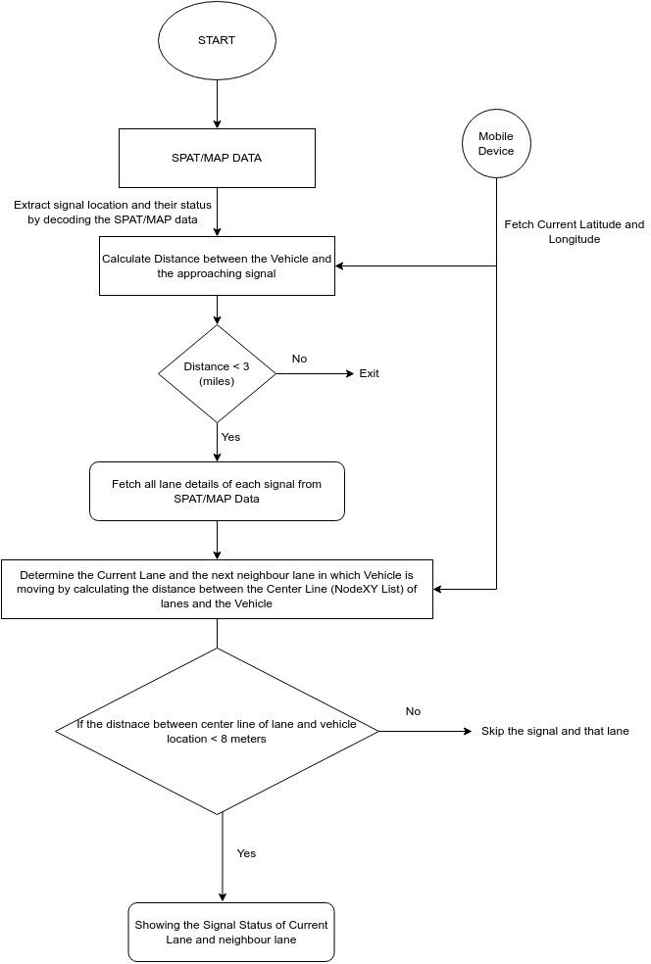

Jenkins pipelines with sonarqube Integration

Requirements:
2GB RAM FOR – JENKINS
MIN 4 GB RAM FOR – SONAR QUBE

Setting up jenkins on Ubuntu-20.04
- Create a vm with the requirements
- Switch to super (root) user: sudo -i (or) sudo su –
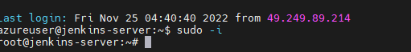
- apt update
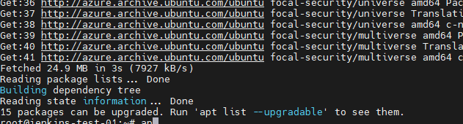
- apt upgrade
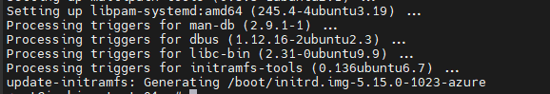
- Install java 11: apt install openjdk-11-jdk -y
- Jenkins can easily be installed on Ubuntu by importing and adding the GPG keys to the system: wget -p -O - https://pkg.jenkins.io/debian/jenkins.io.key | sudo apt-key add
- After adding GPG keys, add the Jenkins package address to the sources list by typing the command given below:
sudo sh -c 'echo deb http://pkg.jenkins.io/debian-stable binary/ > /etc/apt/sources.list.d/jenkins.list'
- After enabling the Jenkins repository, simply update the system’s APT cache once:
- apt update
- To install Jenkins : apt install jenkins -y

- To verify the status of Jenkins service, type the below command : systemctl status jenkins.
- After checking and starting the service, let’s adjust the firewall : ufw status
- If it is inactive enable it -------------- ufw enable
Configure the Firewall for the Jenkins Server Now, in order to configure the firewall for the Jenkins server using the UFW tool, we need to enable the firewall and open port 8080 for remote access from anywhere
- ufw allow 8080
To access jenkins from ui take public ip:8080
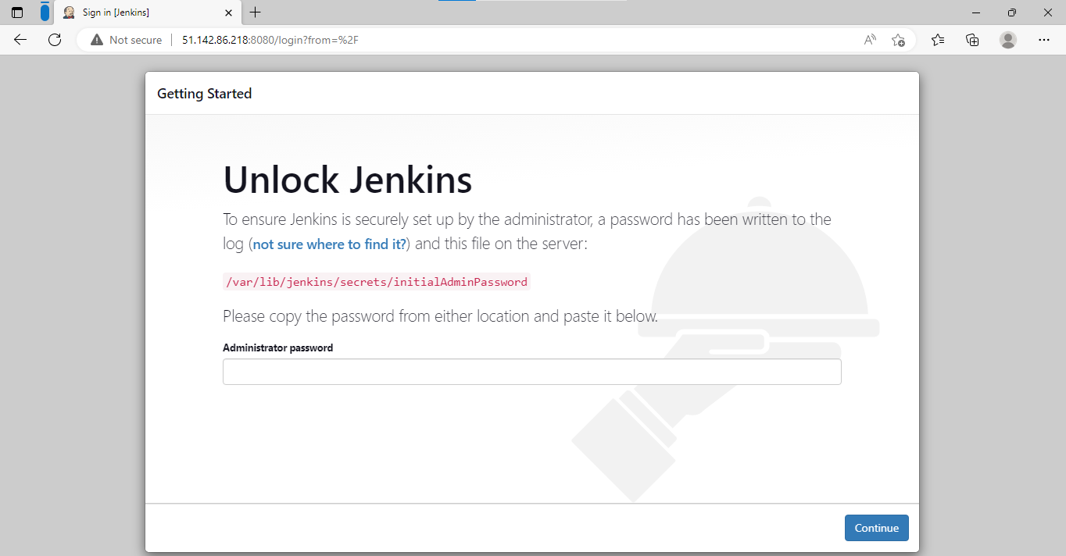

To get initial password cat /var/lib/jenkins/secrets/initialAdminPassword
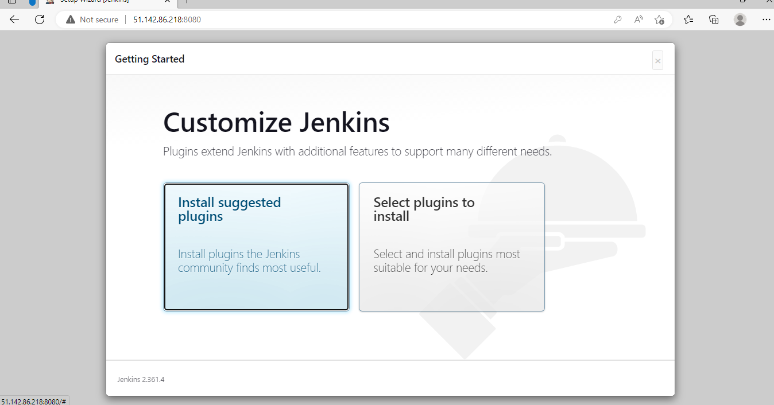

Go for install suggested plugins
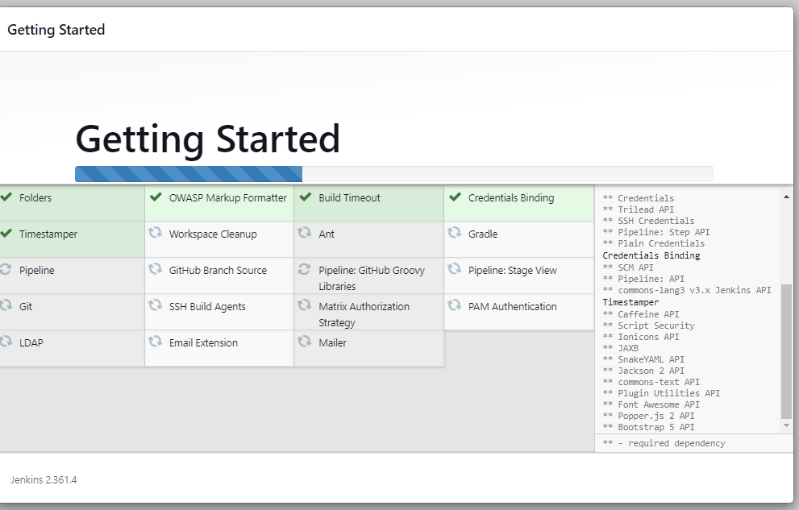

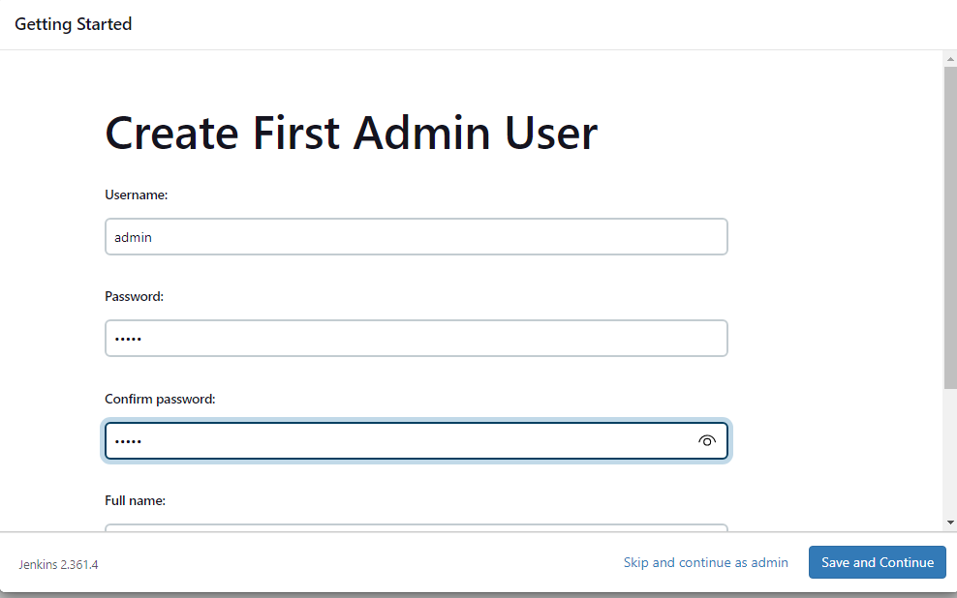

jenkins is ready!!!

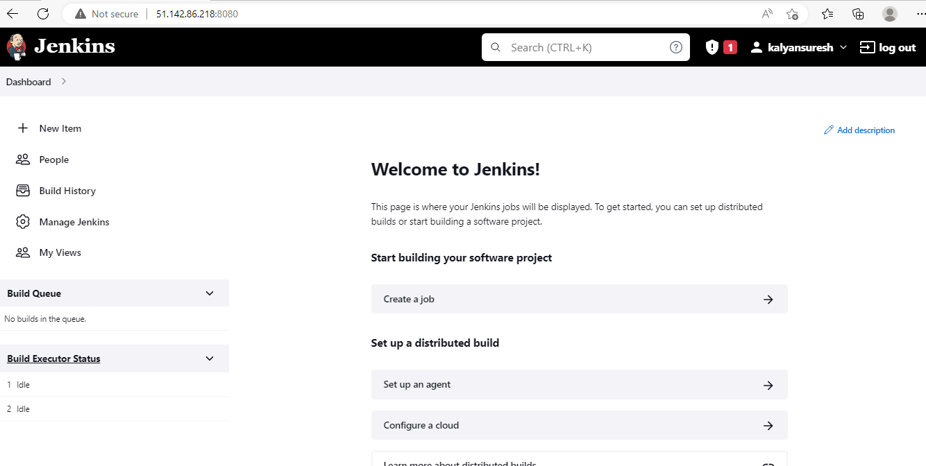

For Integrating the git and sonar with jenkins we need GitHub plugin and sonar-scanner plugin.

Go to manage Jenkins manage plugins and add sonar-scanner and GitHub in plugins.
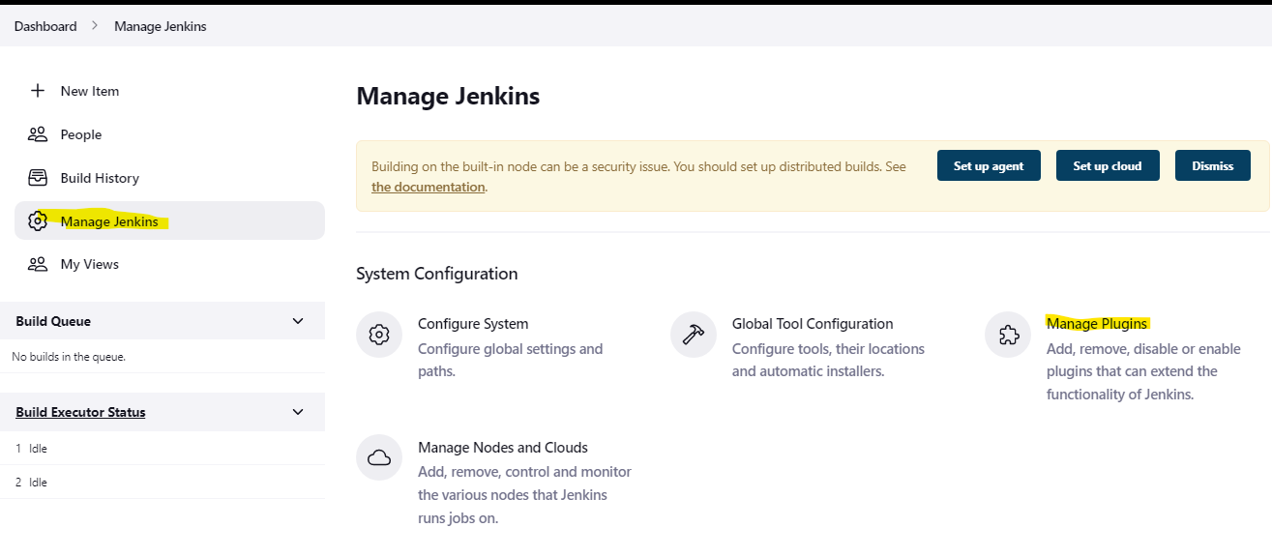

Setting up SonarQube on Ubuntu-20.04
- Create a vm with the requirements
- sudo apt update
- Must need java 11: apt-get install openjdk-11-jdk -y
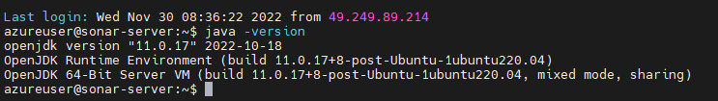
- Install & Setup Postgres Database for SonarQube
- sudo sh -c 'echo "deb http://apt.postgresql.org/pub/repos/apt $(lsb_release -cs)-pgdg main" > /etc/apt/sources.list.d/pgdg.list'
- wget --quiet -O - https://www.postgresql.org/media/keys/ACCC4CF8.asc | sudo apt-key add –
- sudo apt-get update
- sudo apt-get -y install postgresql
- check the status of postgresql:
- systemctl status postgresql

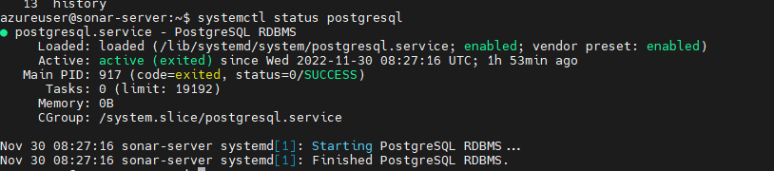

set password for postgre user : passwd postgres
switch into postgres user : su – postgres
create a user in postgres: createuser sonar
switch into psql database to configure sonar database
ALTER USER sonar WITH ENCRYPTED PASSWORD 'admin';
CREATE DATABASE sonarqube OWNER sonar;
GRANT ALL PRIVILEGES ON DATABASE sonarqube to sonar;
Restart postgres database to take latest changes effect
systemctl restart postgresql
systemctl status postgresql
check point: You should see postgres is running on 5432
netstat -tulpn

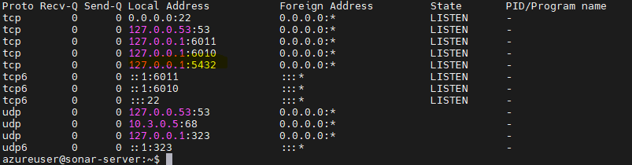

system configurations
Added below entries in /etc/sysctl.conf
vm.max_map_count=524288
fs.file-max=131072
ulimit -n 131072
ulimit -u 8192

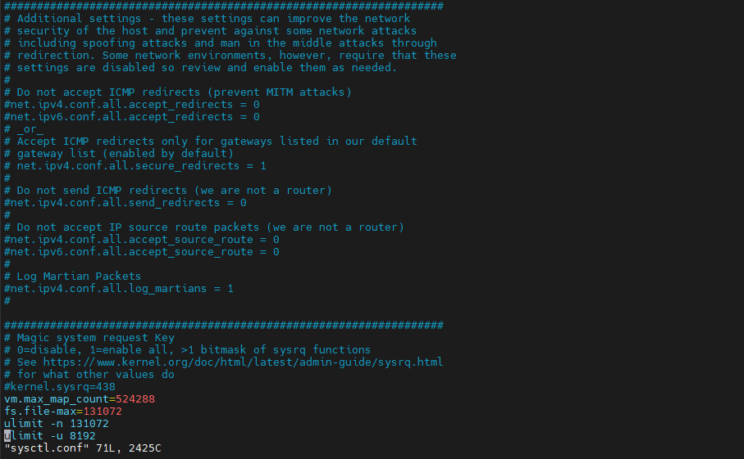

Add below entries in /etc/security/limits.conf
sonarqube - nofile 131072
sonarqube - nproc 8192
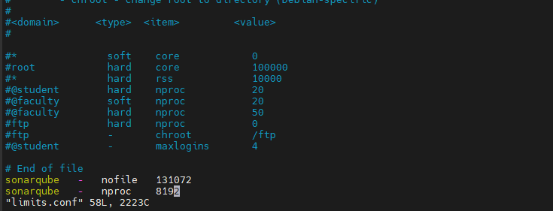

reboot the system init 6 or reboot
wget https://binaries.sonarsource.com/Distribution/sonarqube/sonarqube-8.9.9.56886.zip
unzip sonarqube-8.9.9.56886.zip
Update sonar. properties with below information:
sonar.jdbc.username=<sonar_database_username>
sonar.jdbc.password=<sonar_database_password>
#sonar.jdbc.username=sonar
#sonar.jdbc.password=admin
#sonar.jdbc.url=jdbc:postgresql://localhost/sonarqube
#sonar.search.javaOpts=-Xmx512m -Xms512m -XX:MaxDirectMemorySize=256m -XX:+HeapDumpOnOutOfMemoryError
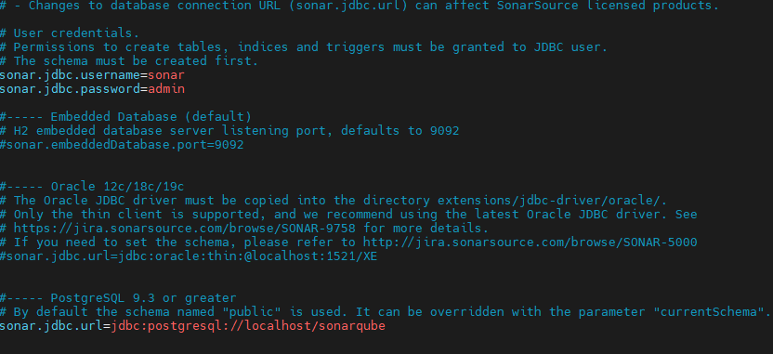

Create a `/etc/system/system/sonarqube.service` file
cat >> /etc/systemd/system/sonarqube.service <<EOL
[Unit] Description=SonarQube service
After=syslog.target network.target
[Service] Type=forking
User=sonar
Group=sonar
PermissionsStartOnly=true
ExecStart=/opt/sonarqube/bin/linux-x86-64/sonar.sh start
ExecStop=/opt/sonarqube/bin/linux-x86-64/sonar.sh stop
StandardOutput=syslog
LimitNOFILE=65536
LimitNPROC=4096
TimeoutStartSec=5
Restart=always
[Install] WantedBy=multi-user.target
EOL

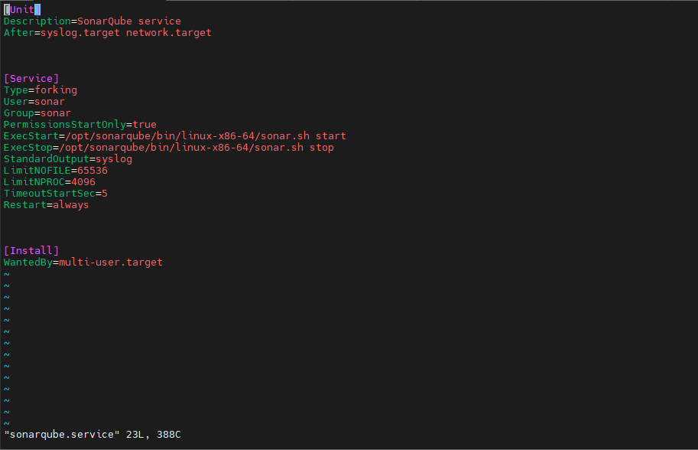

Rename the sonarqube server
mv sonarqube-8.9.9.56886 sonarqube
Add sonar user and grant ownership to /opt/sonarqube directory
useradd -d /opt/sonarqube sonar
chown -R sonar:sonar /opt/sonarqube
Reload the demon and start sonarqube service
systemctl daemon-reload
systemctl start sonarqube.service
vi /etc/profile.d/sonar-scanner.sh
Place the below script
#/bin/bash
export PATH="$PATH:/opt/sonar-scanner/bin"

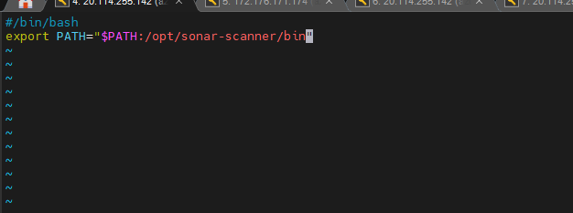

Access it from the browser ip:9000

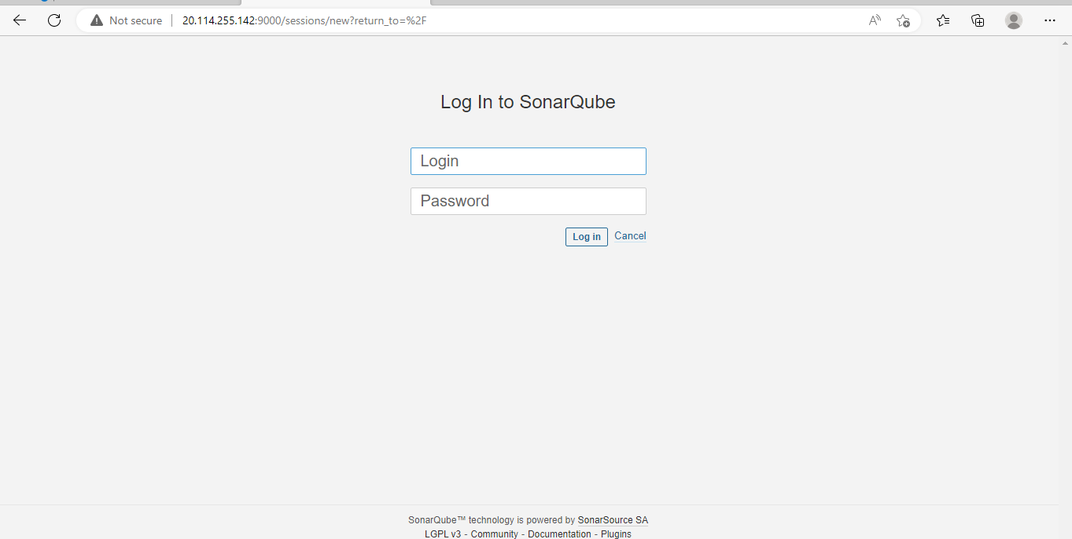
You can see the dashboard after giving the login credentials
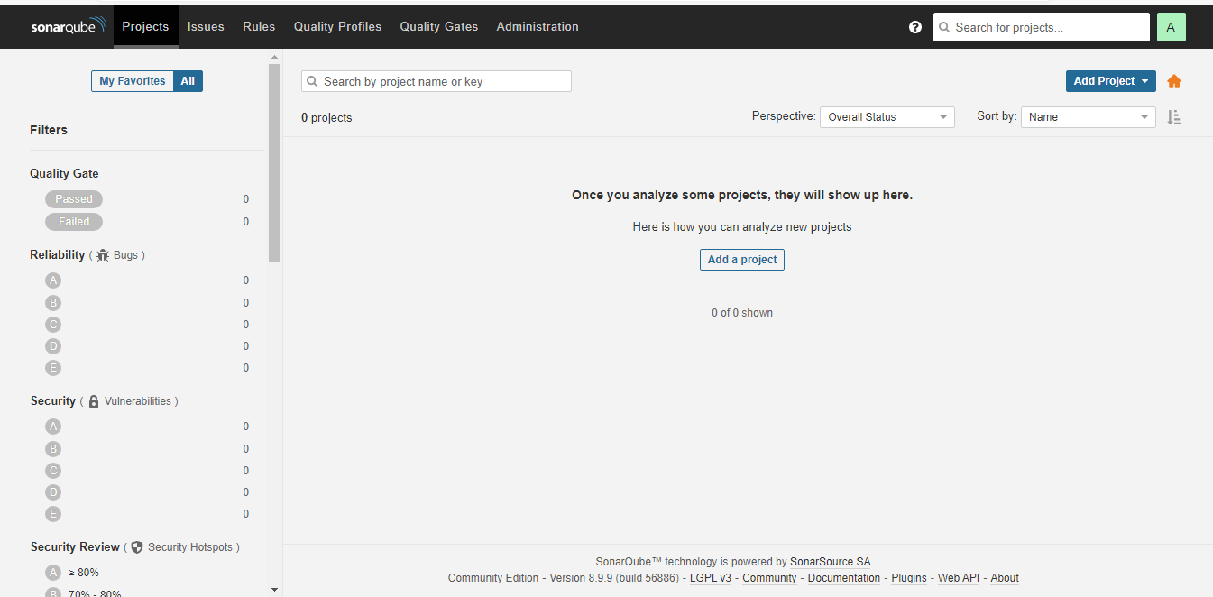
Go to Add Projectmanually
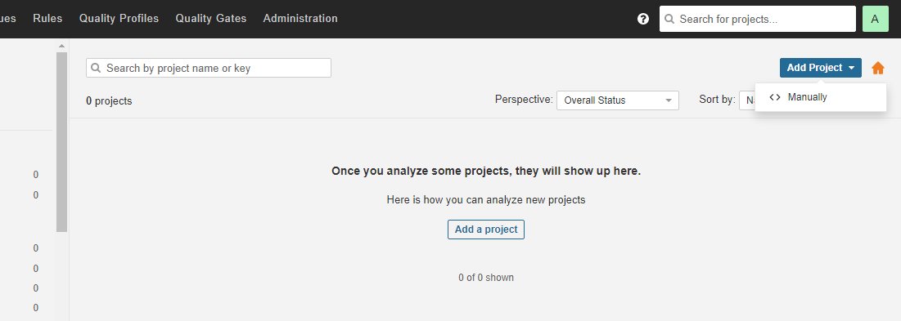
Create a project by giving project key and display name and click on set-up
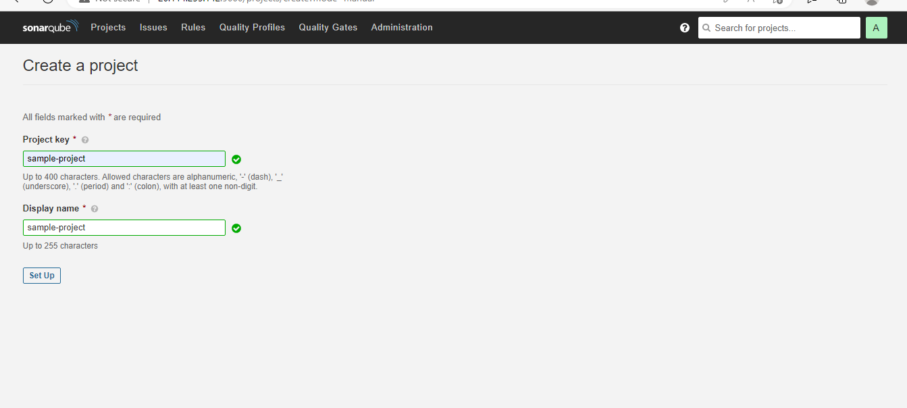
Then after create a token for the project with the project key name
Pass the token in the credentials of jenkins to access the project
SETTING UP JENKINS PIPELINE
Goto Manage jenkins Configure System enable sonarqube server
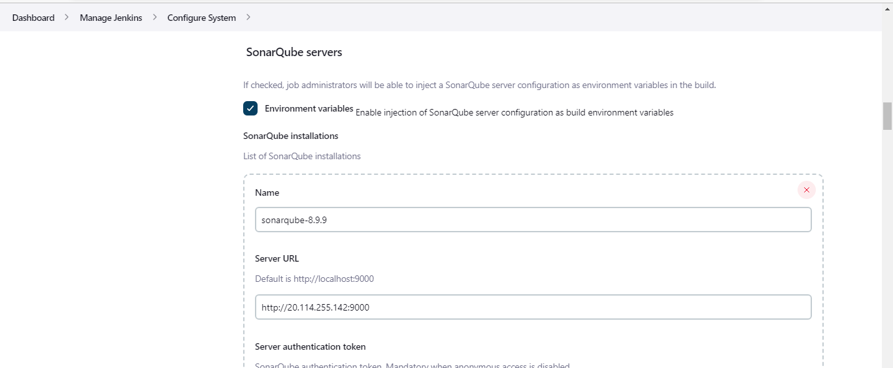

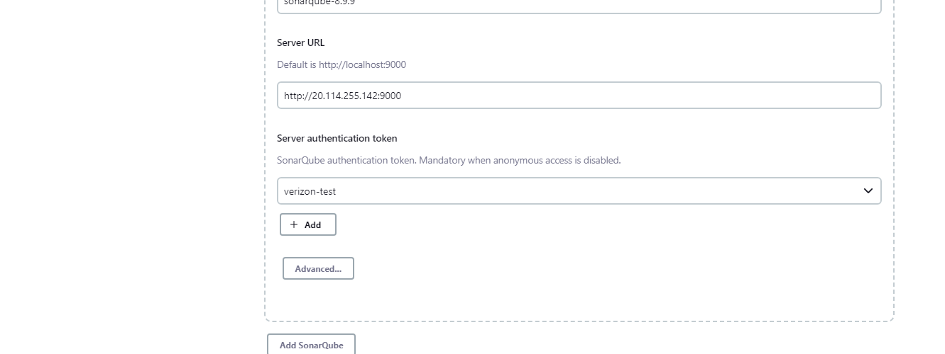
Goto Manage jenkins Global Tool Configuration ADD SonarQube Scanner
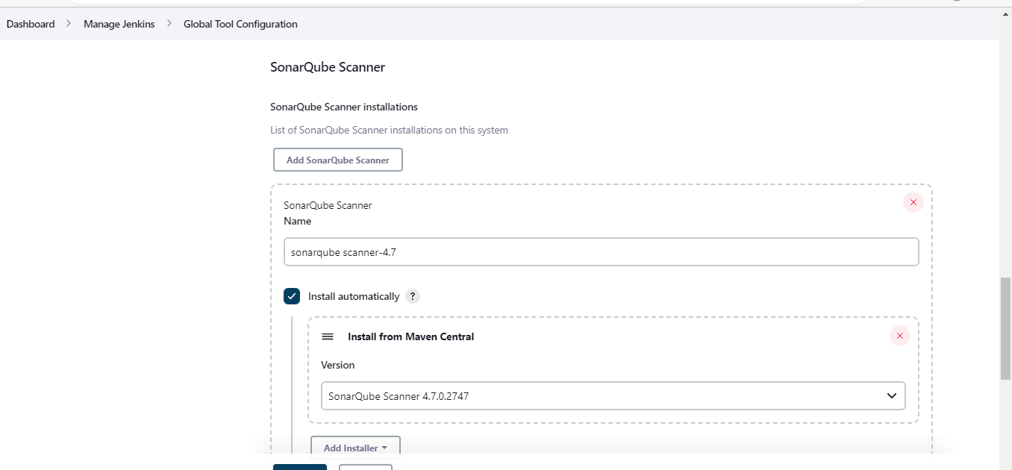
Goto Manage jenkins Credentials global
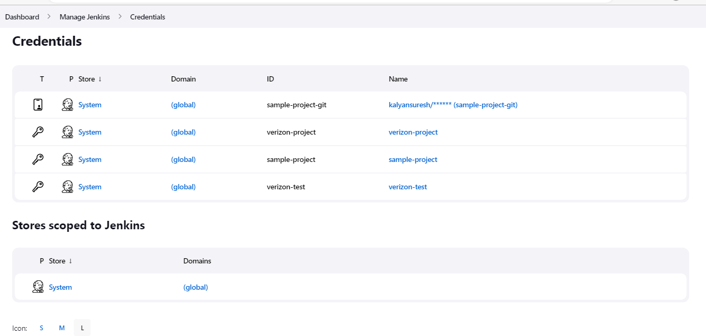

Click on ADD DOMAIN
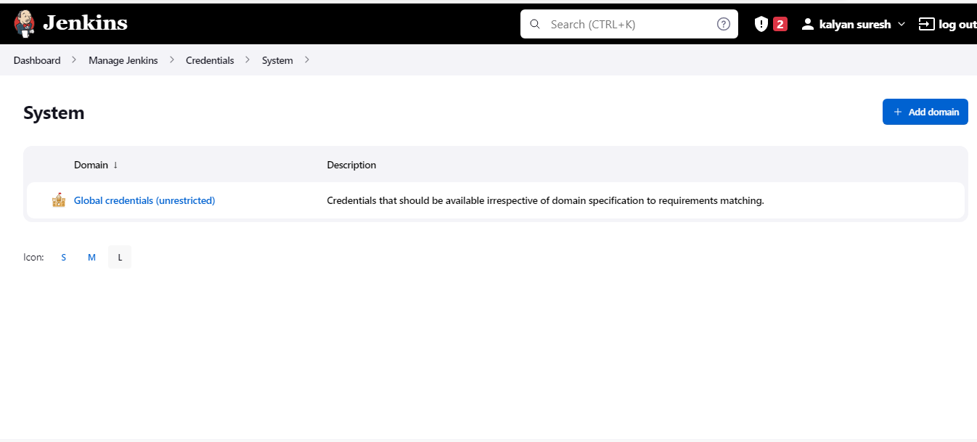
Goto Dashboardclick on new item create a job based on the project -->
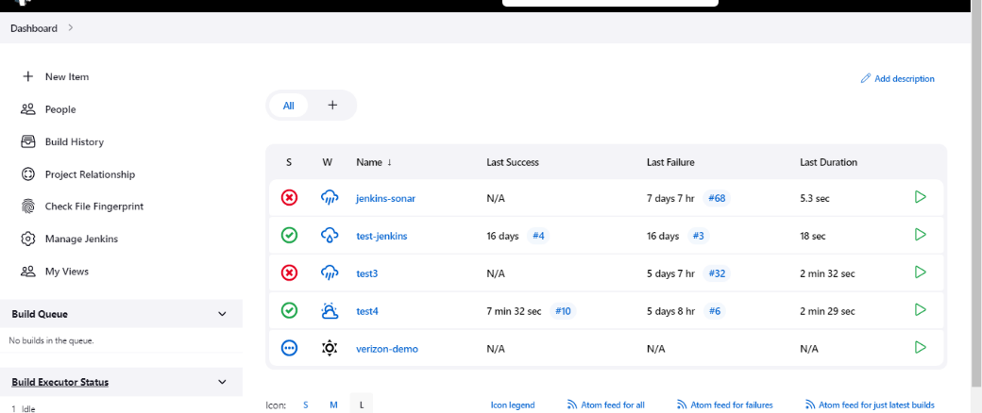

After creating the task goto scmselect git add your git repository URL add your git credentials
In branch select the branch form which the build has to run
In build steps add Execute SonarQube Scanner
In Analysis Properties add below goals
package sonar.host.url=http://20.114.255.142:9000
sonar.sourceEncoding=UTF-8
sonar.projectName=verizon-test1
sonar.projectVersion=1.0
sonar.projectKey=verizon-test1
sonar.login=b0280322b5d3e83380373b9094f6a346bbba3986
sonar.java.binaries=vrsn-middleware/vrsn-gateway-manager/
mvn sonar:sonar
Then apply and save start the build
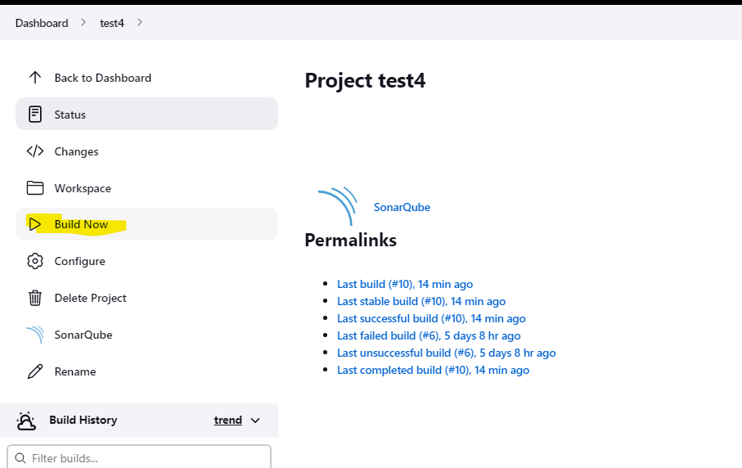

You can see the pipeline running in build history
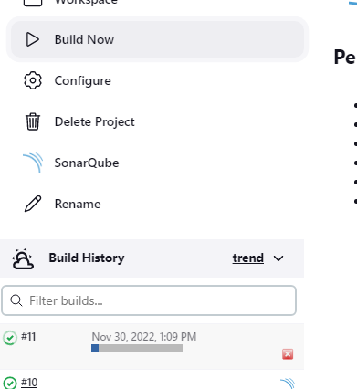

In console output you can see
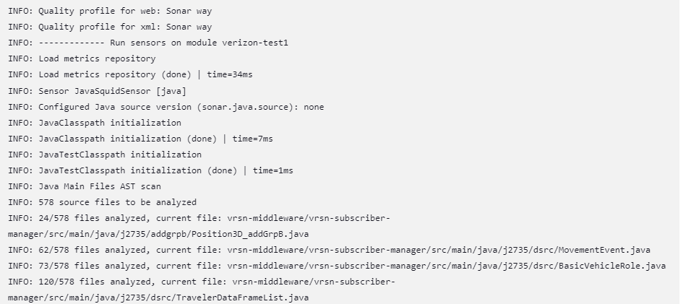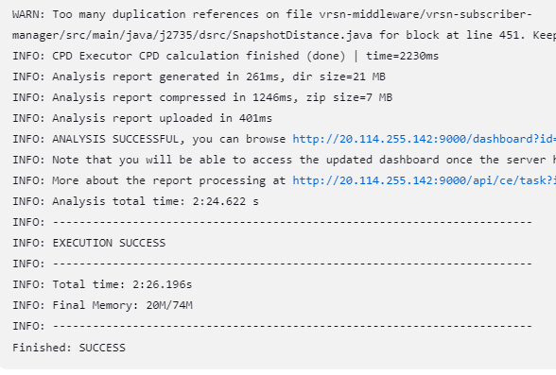

After build success you can see the report in our sonarqube server like below

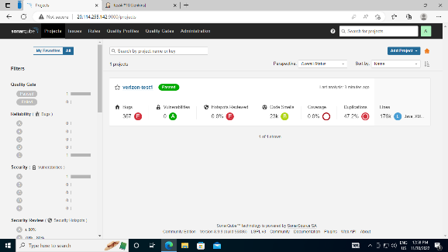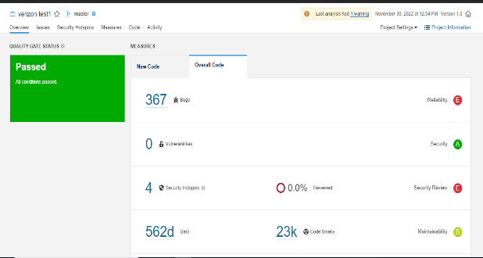

CI/CD Integration Jenkins for android
- Jenkins Installation.
- Setting up Jenkins.
- Configure Jenkins for Android.
- Configure an Android project in Jenkins.
- Build Android project.
- Archiving Artifacts (APKs).

6.1 Jenkins Installation
Jenkins installation is pretty much straight forward for both Windows and Mac! First, we need to download Jenkins from below link.
Jenkins - an open source automation server which enables developers around the world to reliably build, test, and…
jenkins.io
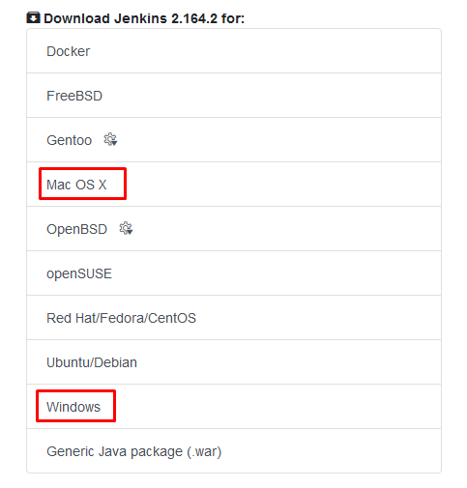
Download appropriate file for Windows/MacOs from the link. For Windows, it will be a zip file that contains a .msi installation file. For mac, it would be a .pkg file that will install Jenkins on MacOs.
For complete reference follow Setting up jenkins on Ubuntu-20.04

Configure Jenkins for Android
Now, this is the tough part! To build Android project in Jenkins, a couple of things are needed as listed below:
- Git
- JDK
- Gradle
- Android SDK Tools
As we have chosen to install default plugins, git and gradle plugins are installed by default! We need to install Java and Android SDK Tools.

Setting up JDK
You can download and install java-jdk (java 11) from here for respective platforms and install it. Java is very easy to install indeed! After JDK is installed, we need to set environment variables for JDK path in Jenkins. The path would be:
<installation_path>/jdk<version>/
To set environment variables for Jenkins, open Jenkins dashboard and navigate to Manage Jenkins>Configure System. Find Global Settings section and tick Environment variables checkbox to enable it.
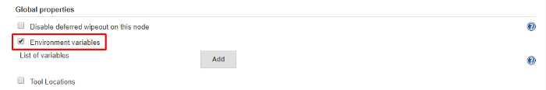
Jenkins Global properties
Click on Add button to add an environment variable. set JDK path as shown below:
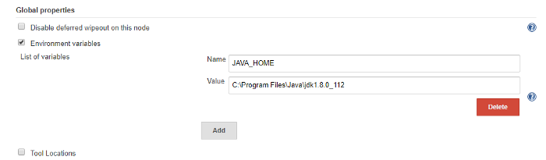
Jenkins Environment Variables
After that, scroll to bottom and click on save.

Setting up Android SDK Tools
If you already have Android SDK installed then you can skip this part and set environment variable for ANDROID_HOME pointing to Android SDK same way we set up environment variable for JDK.
If you don’t have Android SDK tools then you can download it from here. Download zip file for respective platform and unzip it at your suitable location on the disk.
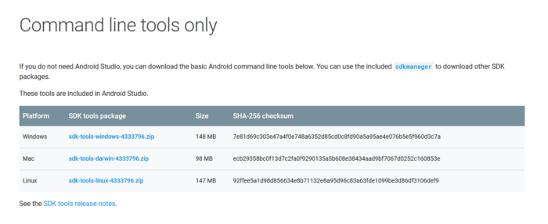
Android SDK tools
Now that Android SDK tools is downloaded; we need to accept all the licenses to use it. open terminal or CMD and navigate to the unzipped folder(named “tools”) and then navigate to bin directory. First, we will update sdkmanager.
For windows:
// updates sdkmanager
sdkmanager --update
For Mac:
// updates sdkmanager
./sdkmanager --update
Now we need to accept all the licenses. run following command.
For windows
// updates sdkmanager
sdkmanager --licenses
For Mac
// updates sdkmanager
./sdkmanager --licenses
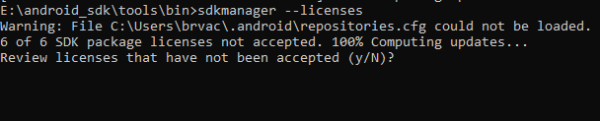
sdkmanager licenses
It will show output like above image. enter “y” and press enter. It will then ask to accept licenses one by one. all we need to do is enter “y” and press enter until all the licenses are not accepted and the following message is not displayed.

If you miss to accept any license then you can run the command and repeat the process. If all the licenses are accepted then running the same command will indicate that all the licenses are accepted!
That’s it! There’s no need to download build tools and platform tools as Gradle 3.0.0 and above does it for you. However, if it doesn’t work for you then you can find sdkmanager commands here to download required tools and platforms.
Now that Android SDK Tools are set up, we need to set environment variable ANDROID_HOME pointing to our Android SDK location. The process is same as we did to setup environment variable for JDK.
Open Jenkins dashboard and navigate to Manage Jenkins>Configure System. Under Global Settings section add new environment variable as shown below:
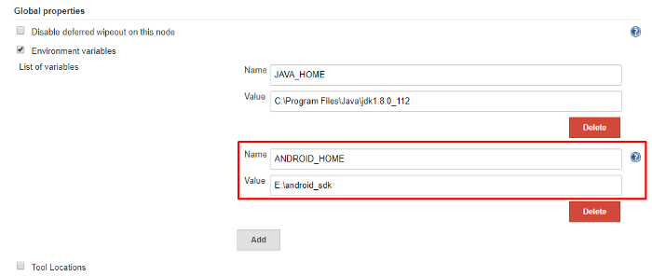
ANDROID_HOME environment variable in Jenkins
Scroll to bottom and click on save.

Configure an Android project in Jenkins
Now that we have set up Jenkins for Android, our next step would be to create a new job to build our Android project. Open Jenkins dashboard and click on create new job or new item. It will the following page.
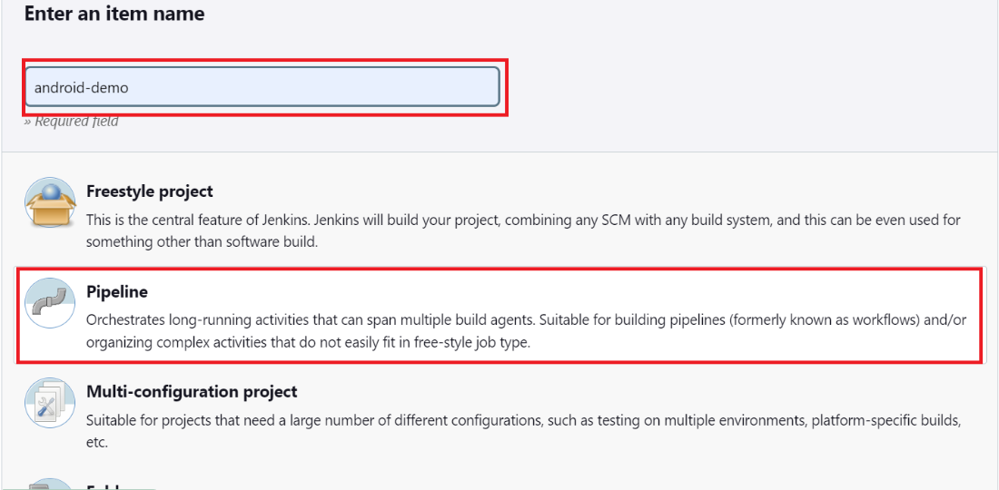
Jenkins Job Style
Enter proper project name and select Pipeline Project style. click on OK button to continue.

Pipeline script for android build

pipeline {
agent any
environment {
PATH = "D:\\gradle\\gradle-7.6\\bin;C:\\WINDOWS\\SYSTEM32"
}
stages {
stage('clone') {
steps {
git branch: 'BRANCH_NAME', credentialsId:’USER_CRED’, url: ‘https://github.com/5GRealityLab /do_frontend.git'
}
}
stage('Build') {
steps {
dir("GlosaNewApp-master") {
bat 'gradle init'
bat 'gradle assembleDebug'
}
}
}
}
}

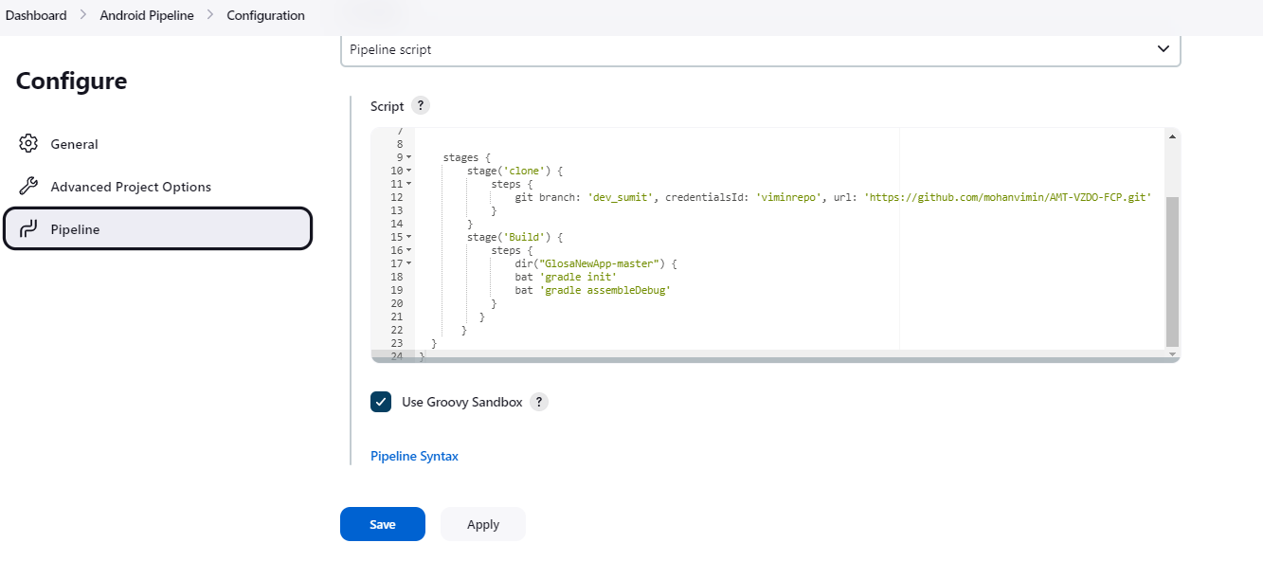
Jenkins - Use Pipeline Script
After that, we need to tell Jenkins which Gradle task we want to execute. Here, we want build our project and generate APK so we will first clean project and then build it. Therefore, clean build command is added. However, you can add any Gradle task here to execute like: assembleDebug. the option — stacktrace is added so that we can see the stack trace of build process if something goes wrong and it fails to build.

Click on save and the setup is done!

Build Android Project
To trigger build, open Jenkins dashboard and select the project/job. On the project/job dashboard, click on Build Now option on the left side panel. After that, it will display running build in Build History section as shown below:
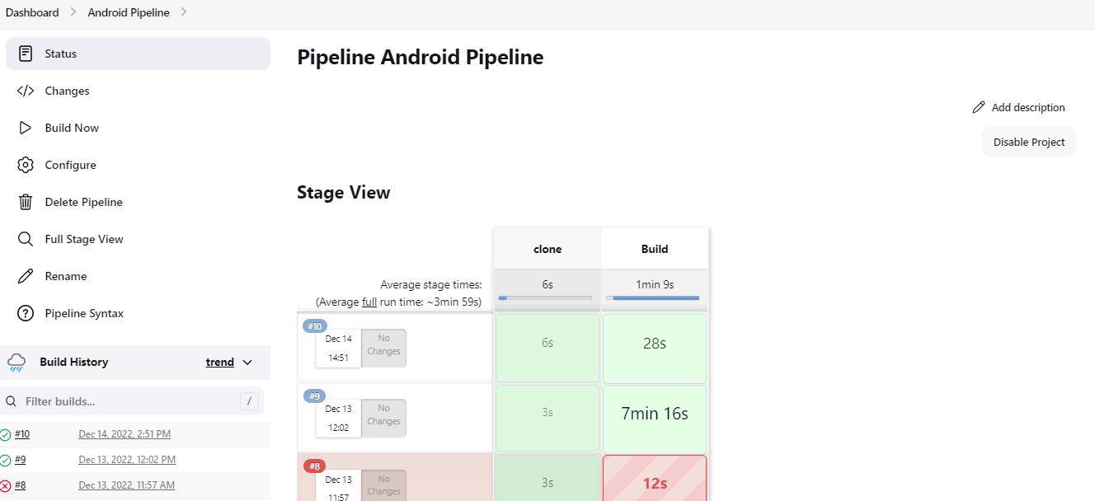
Jenkins Project Dashboard
The blinking gray dot means that the build is ongoing. Click on that dot to see console output as shown below:

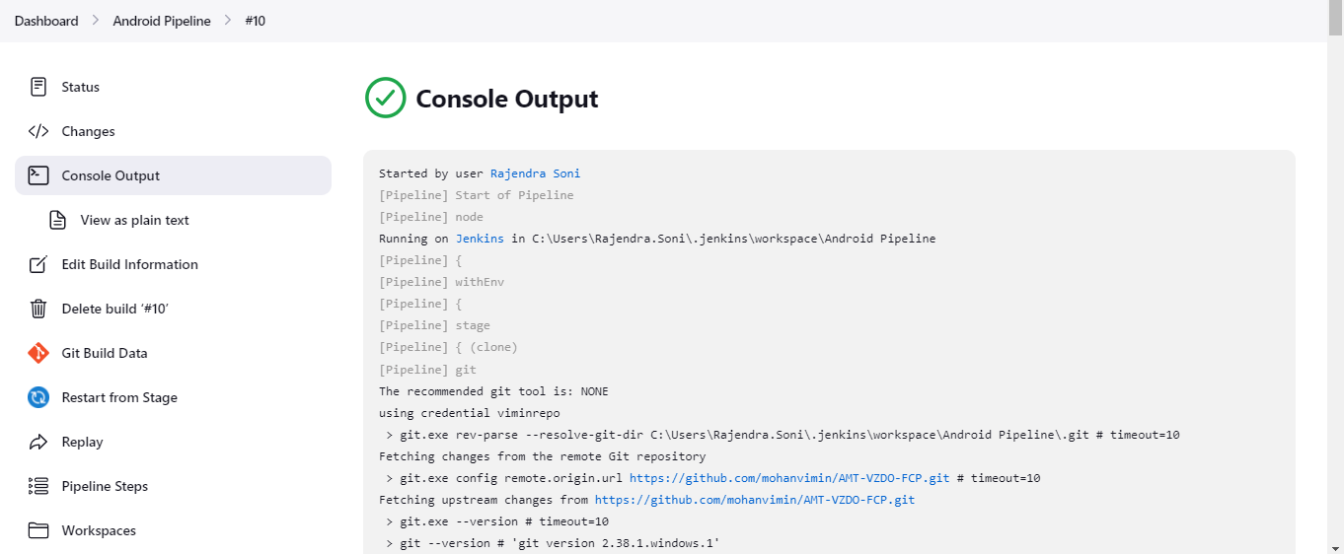
Jenkins Console Output
If something goes wrong then the dot color will turn to red and if everything is okay and build is successful then the dot color will turn blue. For the first time, it will take time to build as it might need to download required Gradle wrapper, platform tools, build tools, etc required files.

Archiving Artifacts (APKs)
So, you build your project successfully but what about the generated output (APK)? How can you get previous build result? Well, Jenkins provides a way to archive outputs of each build. Isn’t it good if you can find every APK that has ever built by Jenkins?
To archive build outputs, open Project dashboard and navigate to configure page and click on Post-build Actions tab. Under Post-build Actions section, click on Add post-build action button and select Archive the artifacts option.
Now we need to tell Jenkins, which files to archive. We want to archive APK that is generated as an output of the Grade build process. So we will provide path for that APK. By default, the APK is stored at the following path
<project-root>\app\build\outputs\apk\debug\
So will tell Jenkins to archive all the APK files in this directory. Now, the path already has context of workspace so don’t need to use ${workspace} variable. We can directly write relative path. It also supports wild cards.
Write output path as shown below:
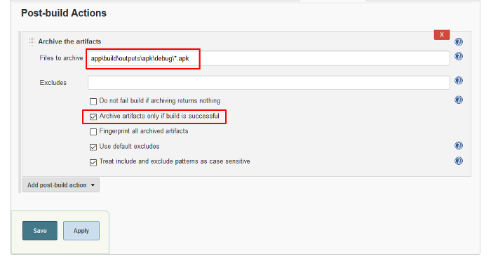
Jenkins Archive the artifacts
click on Advance button and check Archive artifacts only if build is successful option. click on save and build project again. After your project is built successfully, navigate to project dashboard and select the last build from Build History section. on the build dashboard the archived artifact will be shown like this:
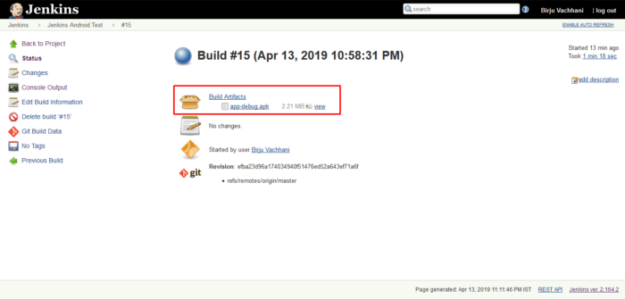
Jenkins Build Dashboard
Every successful build now on will have the artifacts archived. You can also download artifact by clicking on it.

